D3L

System Deployment Plan

##### **Original Plan Date: February Twelve, Twenty Twenty-one**

##### **Revision Date: February Twelve, Twenty Twenty-one**

##### **Revision: 1.0**

# **About this document**

This document initiated in the Plan Phase begins the process of defining the system deployment of the project’s product. The document should be revised during the Define, Design, Build, Test and Deploy phases as the project develops its knowledge and understanding of the operations and support required for the finished product.

It is anticipated that there will be some overlap with other targeted project documents such as Training, and Operations and Support.

It is also anticipated that this document and its subject matter will be transferred over to the product’s operations teams.

**Revision History**

|  |  |  |
| --- | --- | --- |
| Revision Number | Date | Comment |
| 1.0 | February 12, 2021 | Original DoIT PMO Document |
|  |  |  |
|  |  |  |
|  |  |  |

**Table of Contents**

About this document .................................................................................................................... 2

Revision History ........................................................................................................................... 3

1 Introduction ...................................................................................................................... 5

2 Deployment Scope .......................................................................................................... 6

2.1 Objectives ............................................................................................................ 6

2.2 Range of Operation .............................................................................................. 7

3 Deployment Strategy ....................................................................................................... 9

4 Deployment Schedule .................................................................................................... 10

5 Deployment Costs ......................................................................................................... 11

5.1 Deployment Cost Estimates ............................................................................... 11

5.2 Cost Estimation Procedure ................................................................................ 11

6 Deployment Communications Plan ................................................................................ 12

7 Transition to Operations and Support Plan .................................................................... 13

# **1 Introduction**

The D3L project is intended to be a web application service built for the purposes of maintaining a collection of courses administered by a single given educational institution, along with allowing users to record, peruse, and document various related logistical data (e.g. grades, assignment content, peer-to-peer discussion, etc).

The intended customer base includes both students enrolled in and faculty employed at said given educational institutions. The customers expect the user interface to be easily navigable, clean, readable, and intuitive to use; in addition, they expect the relevant operations, including but not limited to adding courses, monitoring grades earned, and interacting with fellow students and faculty, to work as intended. Furthermore, users expect the integrity and security of their data to be maintained at all levels.

We are therefore committed to meeting each of these aforementioned expectations to the best of our ability, and we likewise aim to provide a fully working and robustly implemented software solution geared towards the needs of each and every one of our clients.

# 

# **2 Deployment Scope**

## **2.1 Objectives**

* **Deployment Objectives**
  + Ensure all of D3L’s endpoints and vertical workflows are operational (see Project Objectives)
  + Train a subset of staff to act as technical service representatives and technical support for D3L (see Agency Objectives)
  + Identify potential clients who would benefit from adopting the D3L service suite (see Business Unit Objectives)
  + Market D3L to prospective clients (as identified previously)
  + For each client willing and able to adopt usage of D3L:
    - Contact client to schedule a 2-week period of hands-on D3L training
    - Send supervisor and technical advisory staff to client’s location at the given starting date
    - Guide client’s employees and technical staff to install D3L into their institution’s local IT infrastructure
    - Train client’s technical staff to navigate the D3L interface and ultimately act as D3L technical support representatives within their institution
    - Integrate client institution’s database of students, faculty, and coursework into the D3L framework
* **Project Objectives**
  + Ascertain robustness of all relevant data security and cryptographic measures
  + Ensure all API endpoints are fully functional and working as intended
  + Ensure unit test suites pass with a success rate greater than or equal to 85%
  + Ensure average uptime of pre-production build greater than or equal to 95%
* **Agency Objectives**
  + Enroll a subset of workers into specialized training for the purposes of acting as technical support representatives for the D3L system
  + For each client who has purchased the appropriate license and agreed to adopting D3L at their institution:
    - Send abovementioned D3L technical representatives to the institution for a 2-week introductory period, which will conclude in full installation and integration of D3L into said institution’s technical infrastructure (see Deployment Objectives).
* **Business Unit Objectives**
  + **Beta testing**
    - Identify eligible secondary and post-secondary institutions of education located geographically within the Chicago metropolitan area
    - Market the D3L service to all institutions identified previously
    - Execute the appropriate deployment objectives for each willing respondent (see Deployment Objectives)
  + **Initial release**
    - Identify eligible secondary and post-secondary institutions of education, located geographically within the United States of America
    - Market the D3L services to all institutions identified previously
    - Execute the appropriate deployment objectives for each willing respondent (see Deployment Objectives)

## **2.2 Range of Operation**

The business departments and/or functions impacted by this system are as follows:

* Academic affairs
* Academic advising and transfer services
* Budget office
* Community engagement
* Computer services
* Dean of students office
* Enrollment services
* Facilities management
* Finance and administration
* Financial aid
* Human resources
* Information security
* Payroll
* Registrar
* Student academic success
* Student accounting
* Student affairs
* Telecommunications
* Web services

The geographic scope of this system is as follows:

* **Chicago metropolitan area *(closed beta phase)***
  + Arlington Heights, IL
  + Aurora, IL
  + Berwyn, IL
  + Bolingbrook, IL
  + Chicago, IL
  + Cicero, IL
  + Des Plaines, IL
  + Elgin, IL
  + Evanston, IL
  + Joliet, IL
  + Mount Prospect, IL
  + Naperville, IL
  + Oak Lawn, IL
  + Oak Park, IL
  + Orland Park, IL
  + Palatine, IL
  + Schaumburg, IL
  + Skokie, IL
  + Tinley Park, IL
  + Waukegan, IL
  + Wheaton, IL
* **United States of America *(initial release)***
  + Prioritize major metropolitan areas surrounding accredited college campuses, including but not limited to the following:
    - Baton Rouge, LA
    - Chicago, IL
    - Columbia, MD
    - Des Moines, IA
    - Jacksonville, FL
    - Grand Rapids, MI
    - Greensboro, NC
    - Louisville, KY
    - Naperville, IL
    - Overland Park, KS
    - Phoenix, AZ
    - Portland, ME
    - Rochester, NY
    - San Diego, CA
    - Savannah, GA

# **3 Deployment Strategy**

We will be deploying the system initially to a small selection of target institutions authorized for beta testing; this deployment will be executed with the primary goal of accumulating pre-evaluatory diagnostic information, using a beta version of the D3L system that spans a complete vertical workflow across all major intended functions.

Then, following this preliminary deployment (and pending evaluative review from all involved parties), a finalized production revision will be developed to be the initial version (version 1.0), which itself will be marketed and made available for purchase, download, and integration into the administrative procedures of any educational institution willing to participate.

The beta version’s release will be geographically limited to secondary and post-secondary institutions of education located strictly within the limits of the Chicago metropolitan area. Afterwards, the initial production release (version 1.0) will in turn be limited to purchase and usage by clients strictly located within the vicinity of the United States of America, with priority given to metropolitan districts centered around accredited colleges.

# 

# **4 Deployment Schedule**

[Purpose of this Section: Develop a schedule for site implementations based upon the project schedule, deployment strategy, deployment goals, deployment time estimate and ability to overlap site deployments. Although this schedule is a high level estimate, include any roadblocks or constraints that could drastically alter the schedule.]

* Schedule
  + Every friday or weekend meetings
* Deployment Strategies
  + It is ready to deploy but needs more content
* Deployment Goals
  + Only works in Illinois at the moment
* Deployment time
  + Takes 2 hours to deploy

**5 Deployment Costs**

## **5.1 Deployment Cost Estimates**

At current scale, we are able to use the free tier of Netlify and Heroku.

## **5.2 Cost Estimation Procedure**

The cost of deployment depends on the cost that Heroku and Netlify charge at each tier. They are listed below.

Netlify:

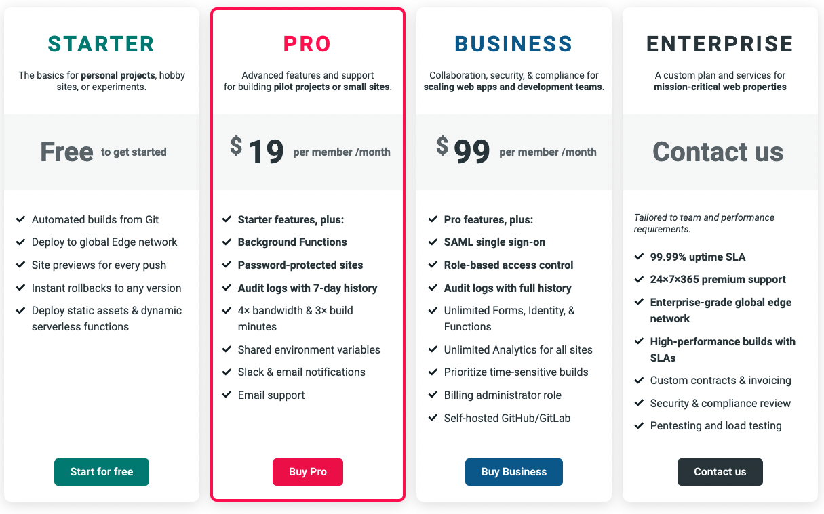

Because we don’t currently need any of the features exclusive to the Pro+ plans, we’re able to stick with the free plans. We’re implementing our own password protection and role-based access control to save money on depending on Netlify to do so. If we do continue to deploy to entire universities, we’d need multiple enterprise solutions for each client.

Heroku:

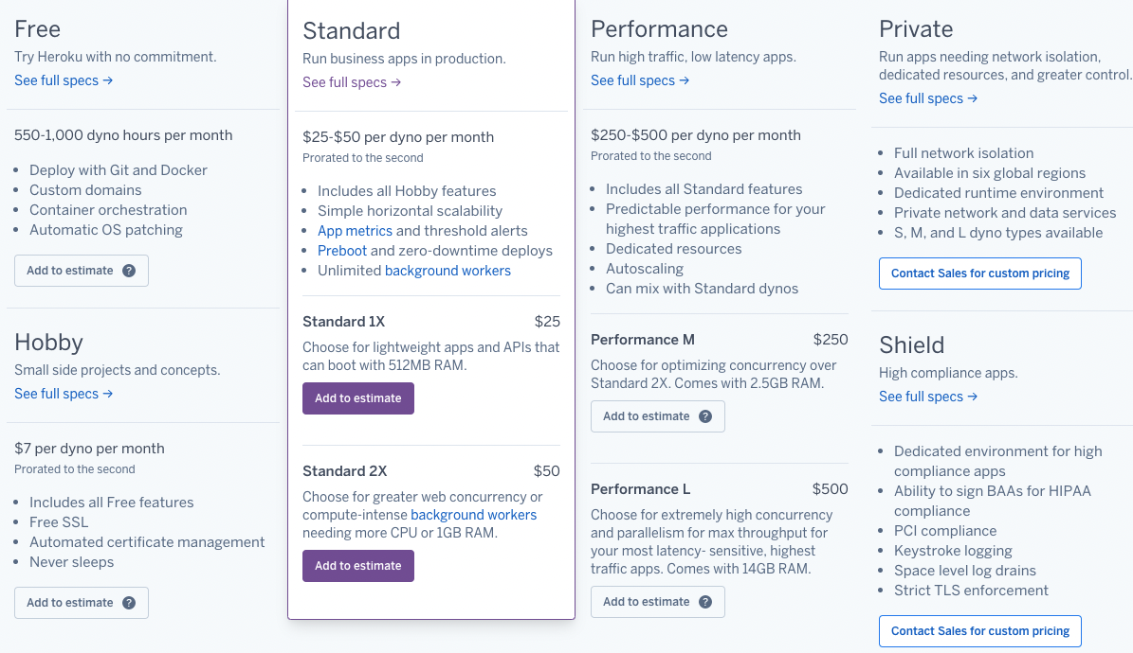

Although our backend through Heroku does sleep if not used for over 30 minutes, it’s sufficient for sandboxing the app. If we were to scale up, we’d probably need the hobby or standard plan so that people don’t have to wait to log in if no one else has used the app recently. If we were to deploy this app to whole universities, we may need a private server per client, and would actually look into hosting through AWS or something similar to save on costs.

**6 Deployment Communications Plan**

Our team has been using Discord for all active communication, which lets us talk in chat rooms and also allows us to meet remotely and discuss design implementations via screen sharing and voice/video chat. We also use GitHub for coordinating the various site implementations as we progress through our development phase.

**7 Transition to Operations and Support**

If we wanted to deploy this from development to actual deployment, we’d need a business plan.

First, the developers would need to push the code to an off-site server. This is to separate the real deployment from beta deployment.

Then, we’d want to test the software. We could have people try to hack it, or try to send unauthorized requests to the backend ourselves. If it passes, we could continue to deploy.

In the beginning, we’d have the developers support the product. This is to keep the fixers close to the client. Any bugs can be immediately dealt with.

Over time, we’d hire operations. A bug ticketing system would help the operations department get customer complaints and organize them for the developers to fix or implement new requested features.